Aerofoil v6.1
Plotting and 4-Axis
G-Code generation
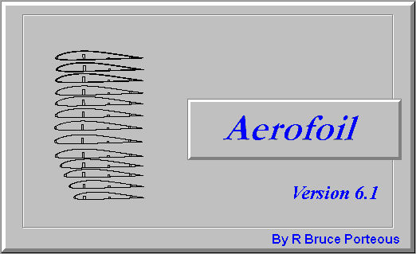

This software is available at:
https://github.com/rbp28668/Aerofoils

By R Bruce Porteous
(c) 2020

Table of Contents
Introduction 3
Installation 4
Running 5
Plotting a Wing 7
Set the Plot Size 7
Set a Grid 7
Create the Structure 8
Adding Internal Structure 10
Spars 10
Cutouts 10
Select Sections to Plot 11
Plotting Cores 12
Modifying the Plot 12
Plotting Ellipses 12
Reference Points 13
Editing a Plot 14
Setting Interpolation Position 14
Inverting and Reflecting Items 14
Deleting Sections and Structure 15
Plot Order 15
Printing and Export 18
Printing 18
Export 18
DXF 18
Postscript 18
LaserJet 19
Driving a Cutter 20
Creating a Cutter File 20
Creating Wing Structure 21
Creating Ellipse Structure 22
Creating Point Structure 23
Creating GCode Structure 23
Creating DXF Structure 24
Converting Structure to a Cut 24
Wing Sections 25
Ellipses 25
Waypoints 25
G-Code Snippets 25
DXF Components 26
Changing Cut Order 26
Home 26
G-Code Output 26
Configuring G-Code 26
Sending G-Code via Network 27
Tool Offset 28
Cutter Geometry 28
Previewing a Cut 29
Loading and Saving 31

Introduction
Now at version 6.1, this program allows you to plot wing sections on paper and to produce G-Code for a separate cutter program. In both cases this includes spars, leading and trailing edges, and skins.

The original It was first written a number of years ago, to run on an early PC-AT with MS-DOS. In this incarnation it's main function was to drive a CNC wing-cutter. When the program was re-written to work under Windows it was extended to include plotting and printing. Now the program has 2 distinct functions – plotting on paper and producing G-Code for a CNC Cutter – in particular the associated Cutter program.

The use of G-Code was introduced in version 6 and now aims to be interoperable with programs such as Jedicut, Profili and Mach3.

Knowledge of the program's provenance is useful when you are using it to plot sections of a wing, a 3 dimensional object, on a 2 dimensional piece of paper. The basic principle is that you define the wing structure, at root and tip (as if you were defining templates for cutting a foam wing) and then plot sections of that structure. This makes tapered wings easy and there is no need for the root and tip sizes or sections to be the same: the program will interpolate between the root and the tip.

In addition to plotting wings it will also plot ellipses or half ellipses for formers. The same principle of defining 2 ends and taking sections along the resultant 3 dimensional object applies as for when you plot wings.

Finally, and this is only really of use when driving a CNC cutter, the program allows you to add waypoints which will guide the cutter between cores.

Installation
Simple – copy aerofoil.exe and or cutter.exe into a folder along with the data sub-directory (which contains the aerofoil sections) on to your hard drive. It doesn't matter where the folder is although it is usually a good idea to put it in a folder where all the users of the PC can access it.
Note that it is possible to build both 64 bit and 32 bit versions which have the suffix _x64 and _x86 respectively. Both these versions have been developed and shown to work under Microsoft Windows 10.
If you want to create shortcuts to the program then point them to aerofoil.exe in whichever install folder you decided on.
Un-install is also simple – delete the program and its data files. There is no install or un-install program. If you created any shortcuts, delete them too.

Running
Open up the folder that contains aerofoil.exe and double-click it. The program should start and give you a blank sheet similar to the picture below.

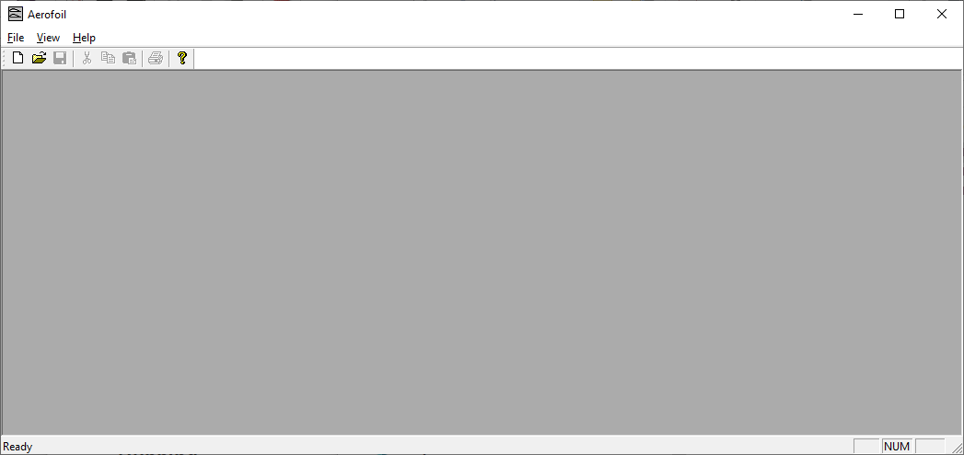
At this point there no plot or cut defined. The File menu can be used to load up a plot file or a cut file or to create a new plot or cut.

File/Open will produce the usual Windows file open dialog. Either select Aerofoil Plot Files (*.plt) or Cutter Files (*.cut) from the drop down as needed and chose the plot or cut file to load.

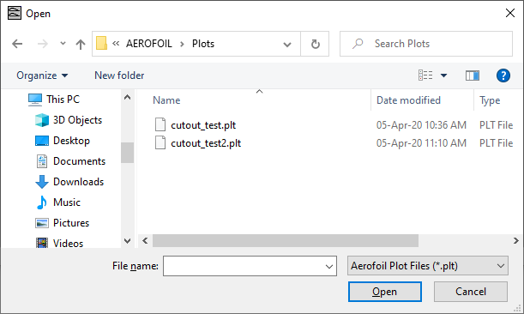
Alternatively, to create a new plot or cut, select File/New. Aerofoil will display the following dialog to ask you whether you want an Aerofoil ( for plotting on paper) or a Cutter for producing CNC output.

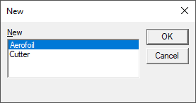
At this point either go to Plotting a Wing or Driving a Cutter.

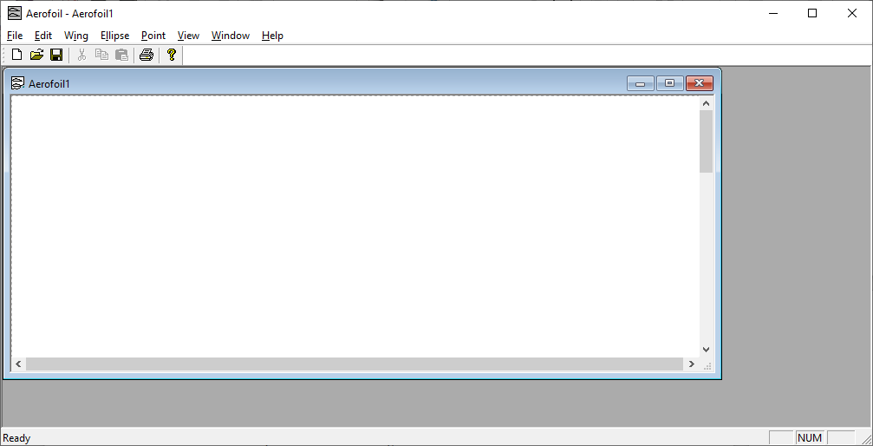
Plotting a Wing
On selecting File/New then Aerofoil you should see a blank plot similar to the following.

Set the Plot Size
Before doing anything else, it's a good idea to set the plot size that you're working with. Select File/Plot Size and enter the plot size into the dialog shown below.

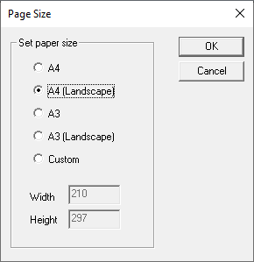
For normal printers, A4 landscape will normally be what you want.

Set a Grid
This step is entirely optional – if you are going to print out the plot and glue it to sheets of balsa for later cutting, it's helpful to have guilde-lines drawn that correspond to the width of the balsa you will be using. To set up these guide-lines select File/Grid. The program will show a dialog similar to the one shown below.

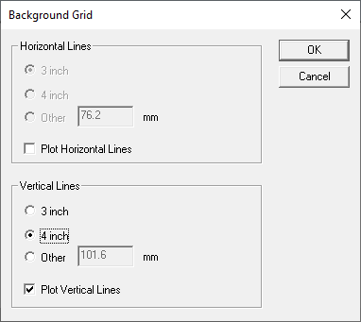
Horizontal or vertical lines will only be plotted if the corresponding checkboxes are ticked. If the box is ticked then you can enter the spacing of the grid. You have 3 options the common 3 or 4 inch size or you can enter another value in mm. Finally click on OK to save the settings. Note that the grid is just a drawing guide and is not saved with the plot.

Create the Structure
To create a new wing, select Wing/New. The program will pop up the standard file-open dialog. This is to allow you to select the root section. Select the data (.DAT) file with the section coordinates for the root. If this is the first time you'll need to navigate to the data folder where all the coordinate files are stored. As soon as you close the first file-open dialog, another one pops up to allow you to enter the tip section.
You should then see the plot of the root section of the wing as shown below.
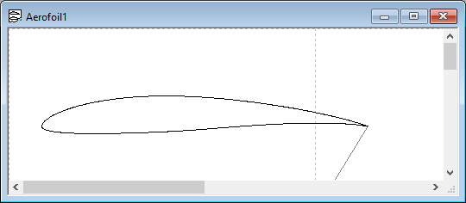

Note that the program in this case has just the root section – modifying this and modifying what is plotted (e.g. chord line, cutting markers, labels etc is covered in Modifying the Plot later.

Now, that the program’s view of the structure probably not what you want. In particular the chord size is almost certainly wrong. To change this you need to edit the basic wing structure. Highlight the section by clicking on it (it should go gray) and either select Wing/Edit or right click and select Edit Wing.

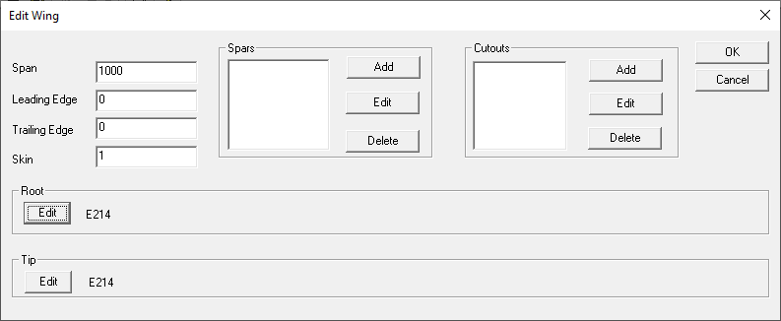

The Edit Wing dialog is shown above. This allows you to edit the basic geometry of the wing, including the (half) span, the size of leading and trailing edges, root and tip section, the size and position of spars and any cutouts in the wing.
Let's change the root parameters – in the “Root” box, click on Edit. You'll see a dialog like the one shown below. You can change the section with the Change button but here we want to change the chord to (say) 200mm.

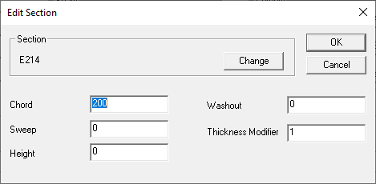
It's worth looking at the other parameters. For plotting on paper the Thickness Modifier entry is probably the most useful. This changes the thickness of the section. For example a Thickness Modifier of 1.2 will make a 10% thick section into a 12% thick section.
The other parameters: Sweep, Height and Washout allow the position and angle of the section to be changed. Not so important for plotting on paper but essential if it's driving a CNC cutter.

Adding Internal Structure
So, now that the basic geometry is set up let's add some structure. First we'll add a ¼ inch leading edge and a ¾ inch trailing edge. The program only accepts dimensions in mm so enter 6.3 for the leading edge and 19 for the trailing edge. Let's also define a skin thickness of 1/16 inch or 1.5mm. The next step is to add some spars.

Spars
In the spars box, click on Add. You should see the spar dialog shown below.

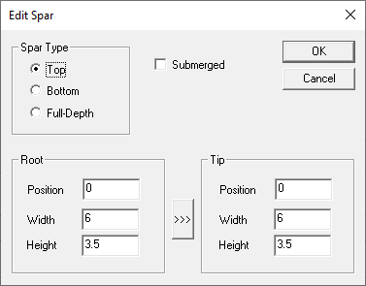
This allows 3 types of spar – top surface, bottom surface or full-depth. “Submerged” determines whether the spar is flush with the surface of the wing or is submerged under the skin. Usually if you've got a balsa skin you'll want a submerged spar. You also need to specify the position and size of the spar at its root and its tip (the position is the distance in mm from the leading edge) A short-cut is to use the “>>>” button to copy the root settings to the tip.
Any number of spars can be entered and they are displayed in a list in the spars dialog.

Cutouts
It’s also possible to enter cutouts in the wing to mark positions for lightening holes or servo leads. In the same way as for spars, cutouts can be added, edited and deleted. If you click Add in the Cutouts box you will see the dialog below.
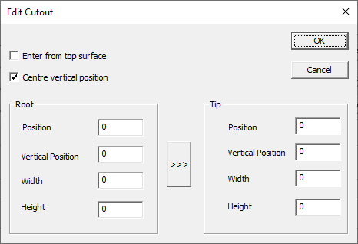

Currently only elliptical cutouts are supported. Position is the position along the chord where you want the centre of the cutout. Vertical Position is relative to the chord line but note the Centre vertical position option which centers the cutout between the upper and lower surfaces. The >>> button will copy the root settings to the tip.
Note that Enter from top surface only applies to generating cuts where the wire has to go into the cutout from one side or other. Normally that would be the lower surface of the wing.

Select Sections to Plot
Once you've set up the wing structure you can plot multiple sections from that wing.
Click on an existing section of the wing to select the wing you want to plot a section of. Then select Wing/New Section from the menu bar. You'll get a dialog asking for the section's position:

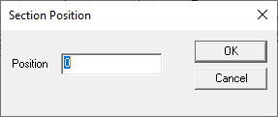
This gives the position, in mm, of this section from the root. One of the parameters of the wing definition is Span. The position, relative to the wing's span parameter determines where the section is interpolated. 0 always plots the wing section – if the wing’s Span is set to 1000 then a Position of 1000 will plot the tip section and 500 will plot a section half way between the root and the tip.
When you click on OK in the Section Position dialog the program will draw another section. You can then click on it's outline to select it and drag it to a new position on the drawing.
Tip: It's useful having a spreadsheet to hand with all the rib positions calculated in mm if you're doing multiple ribs.

Plotting Cores
As well as the full structure of the wing sections the program will also plot templates for foam wings if you don’t have CNC hardware.
Select Wing/New Core from the main menu. The program will draw a core on the drawing, drag it to where you want it. You can change it's position on the span by right clicking it and selecting Position.

Modifying the Plot
Once you've set up a drawing you can modify what's there and how it's drawn. Firstly, anything on the drawing can be moved by dragging with the mouse.
Secondly, there are flags that control exactly what in a wing (or ellipse) is drawn. These affect all the sections of that wing. Select the section of the wing or ellipse and, either right click it and select Wing Flags (for a wing) or, select Wing/Flags from the main menu. You'll get a dialog that specifies a number of options:

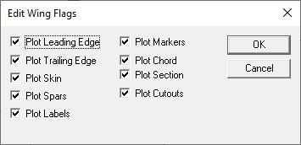
Most of these are fairly obvious. Markers are 10% markers for cutting foam cores by hand. Section determines whether the section is interpolated or both the root and tip are plotted separately.

Plotting Ellipses
The program also allows plotting of elliptical sections for use in creating fuselages etc. The top and bottom heights don’t have to be the same. To add an ellipse, or actually a pair of ellipses as we can interpolate between them much as we do for wing sections, select Ellipse/New from the top menu. You should then see a dialog like the one shown below.
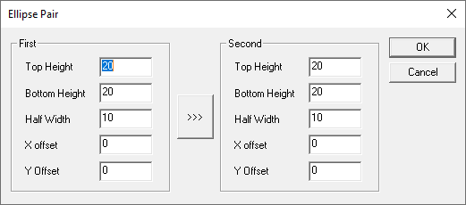

Enter the top and bottom height of the ellipse pair. Half width is the width from the centre to the edge of the ellipse – think radius rather than diameter. As before >>> copies the settings from the first ellipse to the second.

The Flags dialog for an ellipse is simpler than that of a wing:

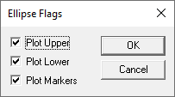
It allows you to specify plotting only the top or bottom halves as well as center markers.

Reference Points
It is possible to add reference points to the plot which are drawn as little “bow-tie” symbols. These can help with alignment over sheets of wood etc.

From the top level menu select Point/New. You should see a dialog like the one below. For a plot there’s no reason to change the values as you can drag its position on the plot anyway.

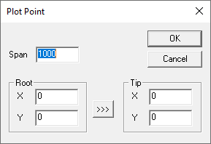

Editing a Plot
Aerofoil sections, ellipses and points can all be dragged around the plot using the mouse. Clicking on an item selects it and you can then able to edit its properties, by :
- Right clicking the item and using the popup menu
- Using the edit menu. Note Edit/Edit Structure is sensitive to the type of object selected.
- Using the Wing/Ellipse or Point menus.

Setting Interpolation Position
All items on the plot are some form of section of a 3 dimensional item which is why even ellipses and points have two ends – first and second or root and tip. Edit/Position will bring up the Section Position dialog shown earlier and below to allow you to interpolate between the two ends.
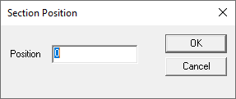

Inverting and Reflecting Items
It’s also possible to invert or reflect the plot of an individual section. Select the section with the mouse and either right click it and select Plot Flags, or, select Edit/Plot Flags from the main menu. You'll see a dialog like the one below:

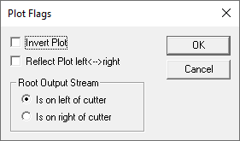

Here, Invert Plot and Reflect Plot left <--> right allow you to flip the section vertically or horizontally respectively. This can be invaluable when trying to cram a set of ribs onto a sheet of balsa.
The Root Output Stream setting is really for a CNC cutter to allow you to switch which end of the cutter cuts the root.

Deleting Sections and Structure
Edit/Delete deletes whichever section is currently selected. That doesn’t delete the underlying structure though. Use Edit/Delete Structure for this which will display a dialog similar to the one below to allow you to select the structure item to delete.

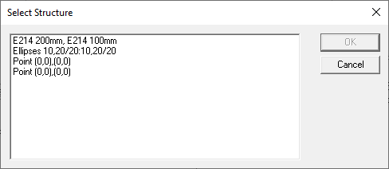
Select the structure item and OK to delete it, Cancel if you didn’t want to delete anything.

Plot Order
Edit/Plot Order allows you to modify the order in which items are plotted. Not normally an issue but this will be reflected in the Postscript or Laserjet (HPGL) output. The Plot Order dialog is shown below. If you select one of the items in the list the buttons to the right allow you to move it to the top or bottom of the list or up and down an entry at a time.
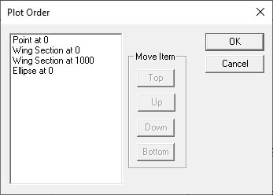

Printing and Export

Printing
It's generally a good idea to set the plot size to match your printer:
File/Set Plot Size gives you the dialog shown below.

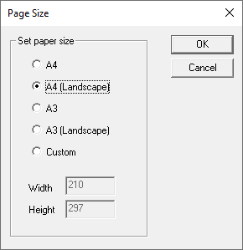
This caters for normal paper sizes and alignments but does allow you to set a custom size as well. The program draws a dotted rectangle around the selected plot size on the screen. Use this as a guide to the printable area – you can drag objects across these lines but they won't get printed.
File/Print and File/Print Preview work as you'd expect with the usual windows dialogs.

Export
As well as printing, Aerofoil can export data in a number of formats: DXF, Laser Jet and Postscript.

DXF
DXF allows you to export sections to be imported into Computer Aided Design (CAD) packages. Aerofoil is itself a CAD program – but a special purpose one. Most general purpose CAD packages will import DXF. To export as DXF select File/DXF Output and enter the name of the file to export to in the Save As dialog that pops up.

Postscript
It may be that you have access to a postscript printer, or want to send a file to someone else who has one. Aerofoil allows export in native postscript. Apart from allowing plot files to be saved and printed later, the postscript asks the printer to generate lines as thin as possible.
To export as Postscript, select File/Postscript Output and enter the name of the file to export in the Save As dialog that pops up.
Note that if you save a postscript file then the usual way to print it is to copy it to the printer device (e.g. PRN: ) not to print it as a text file. Printing it as a text file will make the printer driver encode the Postscript with another layer of Postscript which will waste an awful lot of paper!

LaserJet
In a similar fashion to generating Postscript, Aerofoil will also generate HP-PCL for sending to a Hewlett-Packard laserjet.
To export as HP-PCL, select File/Laser Jet Output and enter the name of the file to export in the Save As dialog that pops up.

Driving a Cutter
Aerofoil provides first class support for generating G-Code to drive a 4-Axis CNC wing cutter. The original program had the ability to directly drive cutter hardware. This has now been moved to a Cutter program which interprets the G-Code and drives the CNC hardware. This has several approaches, not least of which being that the G-Code generated by Aerofoil can be sent to CNC hardware controlled by Mach3 or similar CNC programs.

Creating a Cutter File
After selecting File/New followed by Cutter you should see an empty cut file displayed similar to the one shown below.

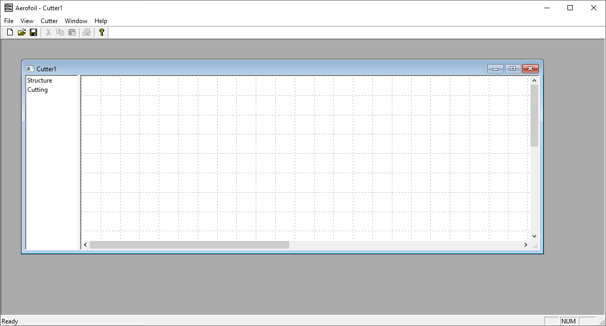
There are 2 areas within the cutter display – a tree view on the left that has (currently empty) Structure and Cutting entries and a display area on the right that shows a graphical display of the current cut file. The separator between the two parts can be dragged left and right to allow more or less display of the tree view.
A tree view is used here as it provides an immediate visual indication of the order in which items will be cut. This is very important when running a CNC system!

Right clicking on the Structure element in the tree will show a popup menu that allows you to create new structure elements as follows:
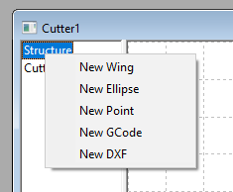

The different types of structure are covered in the following sections.

Creating Wing Structure
Select New Wing from the Structure popup menu. You will then have 2 successive file-open dialogs to select the sections for the root and tip of the wing.
Once you have selected the root and tip sections you’ll see the entry for the wing and can edit it by right clicking the entry and selecting Edit.

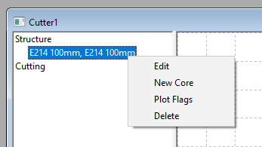
Edit will show the standard Edit Wing dialog shown below and you can change chord, washout, spars, cutouts and leading and trailing edges in the same way as you can creating a plot.
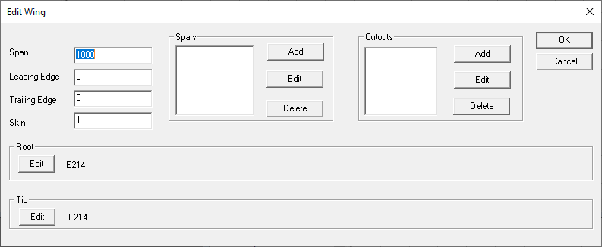

Tip: When creating a wing structure usually just leave height at zero and use sweep to set the relative position between the root and tip. Use the transform feature on the actual cut to determine where the cut goes on the foam block.

Selecting Plot Flags from the wing popup menu will display the Edit Wing Flags dialog that controls whether leading edge, trailing edge, spars or cutouts are cut from the core.

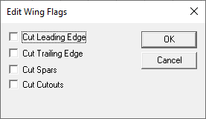

Creating Ellipse Structure
Select New Ellipse from the Structure popup menu. This will show the Ellipse Pair dialog where you can enter the sizes of the ellipses at both ends. As before the >>> button will copy the contents of the first ellipse to the second.

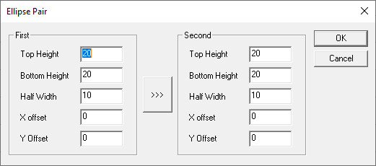

Creating Point Structure
Select New Point from the Structure popup menu. You will see the Plot Point dialog. Note that this defines where the wire of a cutter should go in all 4 axes and so has a position for both root and tip.

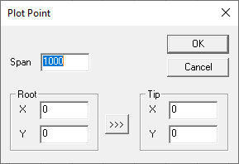
Tip: When setting up the cut path you invariably want the cutter to go via a number of points before it starts cutting the actual foam component. To do this make sure you include a Point at [(0,0)(0,0)] in the structure which will then allow you to create various waypoints before, between and after the actual components.

Creating GCode Structure
Select New G-Code from the Structure popup menu. This will pop up an Edit G-Code dialog where you can add a small snippet of G-Code. See the Cutter manual for more details of G-Code.

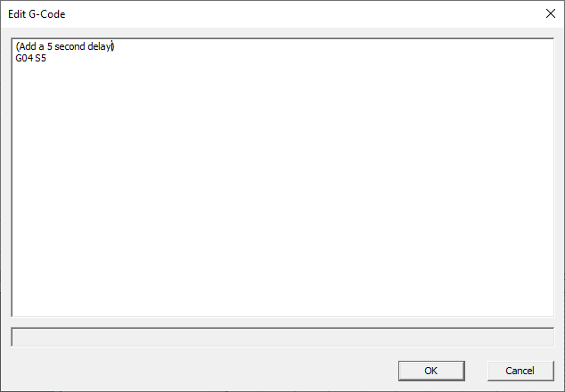

Creating DXF Structure
Select New DXF from the Structure popup menu. This shows a file open dialog to allow you to select the DXF file to import.

Converting Structure to a Cut
Once the structures that you want to cut are defined you need to set up the cut. Structure specific options are discussed below but there are a few concepts that are worth touching on first:

- All the cuts or cutter actions (bar Home) are produced from corresponding structure item’s right click menus.
- Most cut items can be transformed by reflecting, inverting or setting their position. This includes wings, ellipses, points and DXF imports. G-Code snippets can’t be transformed. Use of transforms is the reason why generally it’s best to leave positions alone in the structure.
- All the cuts can be deleted from their right-click context menu.
- All the cuts can be moved up or down the cutting order using their right-click context menu.
- Deleting a cut doesn’t delete the underlying structure.
- Deleting a structure element deletes all the cuts that rely on it.

The Transform dialog is shown below. Invert Plot and Reflect Plot allow the cut to be inverted (upside down) or reflected left to right (mirror image) respectively. Whilst convention has the root on the left side of the cutter it’s possible to swap sides using the Root Output Stream options.
The Root X and Y offsets and Tip X and Y offsets allow the exact position of the item to be defined in machine space. This is the usual way to position a core, ellipse, cut point etc. Note that the transform does work on a DXF import as well.

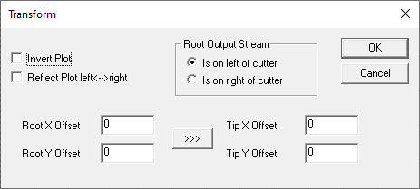

Wing Sections
Right click on the wing structure you want to cut and select New Core from the popup context menu. You should now see a Wing Core entry in the Cutting list. Transform and move up/down the cutting order as needed using its right-click context menu.

Ellipses
Right click on the Ellipses structure you want to cut and select New Cut from the popup context menu. You should now see a Wing Core entry in the Cutting list. Transform and move up/down the cutting order as needed using its right-click context menu.

Waypoints
Right click on a Point entry in the structure. You now have a choice of New Move or New Cut in the context menu. Moves are for use when the wire it outside the foam block and will go at full speed. Cuts are for when you’re cutting foam during the move and will move at the current feed rate. Your should now see a Move to point or Cut to point entry in the Cutting list. Transform and move up/down the cutting order as needed using its right-click context menu.

G-Code Snippets
Right click on the G-Code Snippet structure entry you want to cut and select New Cut from the popup context menu. You should now see a G-Code Snippet entry in the Cutting list. Move up/down the cutting order as needed using its right-click context menu.

DXF Components
Right click on the DXF Object structure entry you want to cut and select New Cut from the popup context menu. You should now see a DXF Object entry in the Cutting list. Move up/down the cutting order as needed using its right-click context menu.

Changing Cut Order
Each item can be moved up and down the cut order by using its right click menu and selecting Move Up or Move Down as appropriate. Changes to the order should be visible in the display in the right hand pane – hopefully it should be obvious if there’s a move or a cut straight through a part!
Cut items can also be deleted using their right click menus.

Home
The only cut item that can created without structure is the Home command i.e. recalibrate the cutters position against its home or limit switches. To do this right click on the Cutting item in the tree structure and click on Home in the popup as shown below.

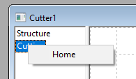

G-Code Output
Aerofoil does not drive a 4-axis cutter directly. Instead it outputs G-Code that the companion Cutter program reads and uses to program the cutter movement. G-Code is a fairly standard way of defining CNC movement. The G-Code that Cutter accepts is defined in the Cutter manual but here are the highlights.
The 4 axes are called X, Y, U, V by default which correspond to left horizontal axis, left vertical axis, right horizontal axis and right vertical axis. 0 positions are at the bottom and closest to the front of the cuter so that +ve movement moves away and up. Axis names are configurable as some systems use X,Y,A,Z.
Default feed rate is set in mm per second but can be over-ridden.
Cutter implements various commands for enabling/disabling the stepper motors, turning the wire on and off and moving the motors. Some of these can be over-ridden.

Configuring G-Code
The emitted G-Code can be configured by selecting Cutter / Configure G-Code Output. The system will display the following dialog which allows various parameters to be set.
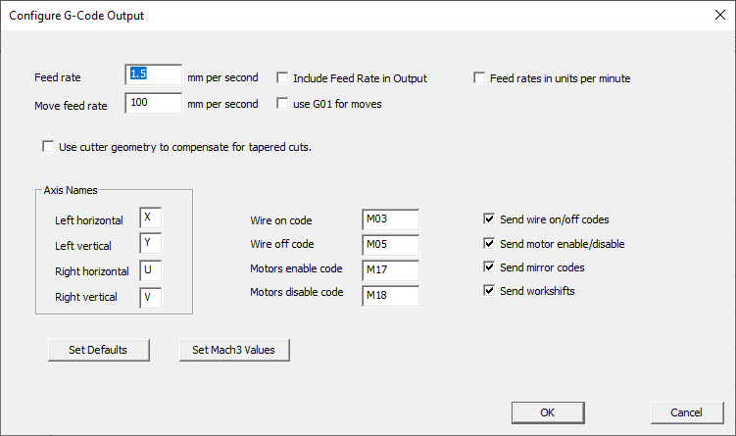

The feed rate can be set in mm per second. It is not included in the output by default (so that the same G-Code program can be used to cut different materials).
Some systems use G01 for fast moves in which case both a Feed rate and a Move feed rate need to be entered and Include Feed Rate In Output, use G01 for moves should be checked. Usually if this is done (for Mach3 for example) then Feed rates in units per minute should also be checked.
The Cutter program is aware of the geometry of the cutter and will compensate for the edges of the foam block not bing right up to the cutter axes when cutting a tapered wing. Aerofoil can also do this calculation for systems that cannot compensate for the taper and the G-Code coordinates will reflect that compensation if Use cutter geometry to compensate for tapered cuts is set.
As stated earlier the 4 axes names can be set using the Axis Names section.

Machine codes for turning the wire on/off and enabling/disabling the motors can be set and optionally written to the G-Code output.
Send mirror codes and Send workshifts allow the commands to reset mirroring and workshifts to be included or excluded from the G-Code preamble.

Sending G-Code via Network
As well as saving a G-Code file to disk that can be read in late, Aerofoil can send G-Code directly to Cutter over a network using TCP-IP. For this to work you need to enter the host (the machine name or IP address) where Cutter is running and the port it is listening on. By default Cutter listens on port 8193. Note that using localhost or 127.0.0.1 as the host will send the data to the machine you’re running Aerofoil on.

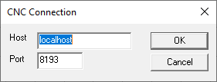
To actually send the data select File/CNC Output. This then streams the data to the given host and port. If you haven’t already setup the CNC connection you’ll see the dialog above before the data is sent and will need to enter a valid host and port.

Tool Offset
Tool offset allows you to compensate for the width of the kerf produced by the hot wire or “melt-back”. Select Cutter/Tool Offset from the top level menu and you will see the following dialog.

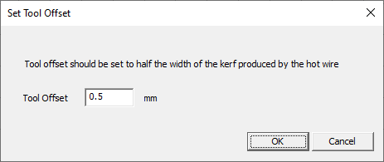
Note that the tool offset is half the width of the kerf - it’s the distance the software needs to move the wire out so that the edge of the cut is in the desired place.

Cutter Geometry
Setting up the cutter geometry allows Aerofoil to do 2 things:
1. It can calculate the correction needed to cut tapered wings, both in simulation and, if selected, when the G-Code is generated.
2. It can scale diagrams correctly to show the available travel.

To set up the cutter geometry select Cutter/Cutter Geometry from the main menu. You will then see a dialog like the one shown below.
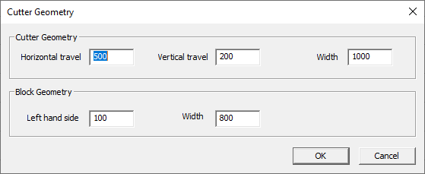

Cutter Geometry allows you to set the horizontal and vertical travel as well as the cutter width. The left hand side of the block and its width then establish the relationship between the block and the cutter. Note that the block’s left hand side and width must be less than the cutter width. All dimensions are in mm.

Previewing a Cut
Before sending the G-Code to the cutter it is worth previewing the cut. To do this select Cutter / Preview Cut Path. You’ll see a dialog similar to the one below displayed and the cutting path will be animated. Note that this is showing the path the actual cutter takes – when cutting tapered wings this will not be the exact shape traced on the edges of the foam block by the wire.

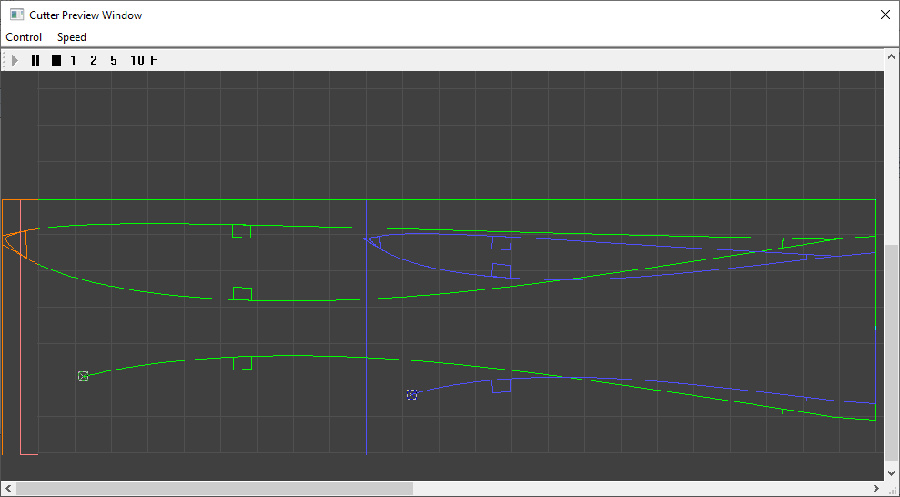
The screenshot above shows the path of the cutter animation – it’s already cut one core and is part way through the top surface of another. Note the colour coding:
- Green is the path taken by the root end of the cutter.
- Blue is the path taken by the tip end of the cutter.
- Cyan (not shown) where both axes are cutting exactly the same point at the same time.
- Red is where one or other path has gone out of limit – less than zero or greater than the cutter travel.
Red is usually the result of faulty programming, in particular cutting a tapered wing where an axis cannot travel far enough to ensure that the wire is in the correct position on the edge of the block.
The simulation can be started, stopped, paused and restarted. The simulation speed can also be changed using the 1-5 and F (full speed) buttons.

Loading and Saving
Drawings can be loaded and saved. On the File menu:
- New creates a new drawing or cut file.
- Open opens an existing (.plt) drawing file (or .cut cutter file).
- Close closes the current drawing.
- Save saves the current drawing to file.
- Save As saves the current drawing to file with a new filename.
It's worth noting that the save format is XML. There is no schema per se, but looking at saved files will give a good guide. These files can be edited by hand if necessary although it's not usually necessary. Once instance where this may be necessary is if the aerofoil data (.dat) files are moved so the saved drawing files no longer reference valid aerofoil files.

